Technology in Education Lesson Plan Week (2)
Objectives:
- Identify tools for more advanced learners such as Zoom, Ring Central, Google Handout, and Microsoft Teams.
- Understand what Google tools are and what Microsoft tools are.
- Understand what Canvas, Blackboard, and Google Classroom is.
Materials needed:
- Computer
- Notebook/paper
- Pen/pencil/Markers

Teacher | Learner
Opening ( 5 minutes):  Start Learners off with a Pre-Quiz.  Teacher- Hello!  Today we are going over some more advanced tools that learners and students are using in the classroom today. I am speaking to you guys through a video communications app, called zoom, that allows you to set up virtual video and audio.  There are other tools like Zoom. Such as Ring Central, Google Hangout and Microsoft Teams.  Document this down.  (Objective: Expose the learners to these more advanced tool .) | Pre-Quiz:  - What Is Zoom?  - What are other tools just like Zoom?  - What is google classroom and what are other tools like it.  - What are Google tools and what are Microsoft tools?  Learner- Research and document other tools that advanced learners use.
10 Minutes
Teacher- Introduce Google Classroom because most students are using it in the classroom right now.
Teacher Say: Introduce Google classroom.
- Google Classroom is a free web-based platform that integrates all Google Services for Education accounts. Meaning, students and teachers have access to Google Docs, Gmail, and Google Calendar. Most if not all students are using Google Classroom.

Teacher- Other tools that students are using in the classroom are Canvas, and Blackboard. I will explain each one.
10 minutes  Google tools vs Microsoft tools Lecture  Teacher- Google and Microsoft are very similar and very different. They both host a wide range of tools that many people use not just students. Today we will be expanding upon Microsoft 365 and Google Workspace.  Both Microsoft 365 and Google G Suite have:  - Business email and shared calendaring services  - Online storage or (Cloud)  - Productivity apps for creation and collaboration  - Corporate communication tools, including messaging, online meetings, and video conferencing.  - Overall offer including but not limited to more reliable emails, file storage, calendar, notes, video conferencing tools, etc.  Google’s G Suite:  Includes Gmail, Google Drive, Google Docs, Sheets, Slides, Calendar, Keep, Hangouts, and other Google apps.  Microsoft Office 365:  Includes Outlook, OneDrive, Word, Excel, PowerPoint, One Note, Skype, and other Microsoft apps. | Learner- Take notes.
5 Minutes  Post Assessment:  Teacher- Learners I would like to end this off by you guys writing down 5 things you learned and 3 things you still have question on.  Teacher- Now take the 3 things you have question on and try to do some research to see if you can find an answer to those questions. | Learner: Write down 5 things you know, and 3 things you still have questions on. Research.

SMART BOARD
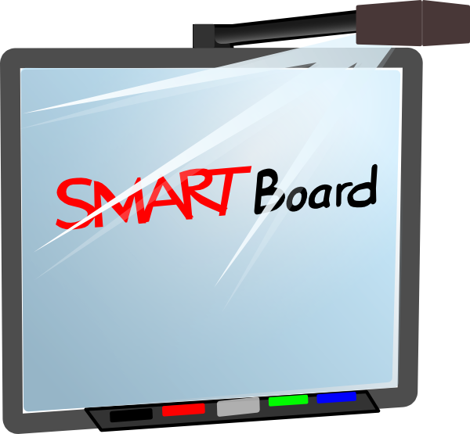

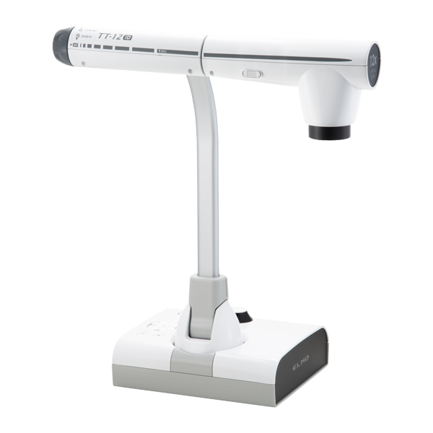
ELMO/DOCUMENT CAMERA

LAPTOP

MOUSE

IPAD

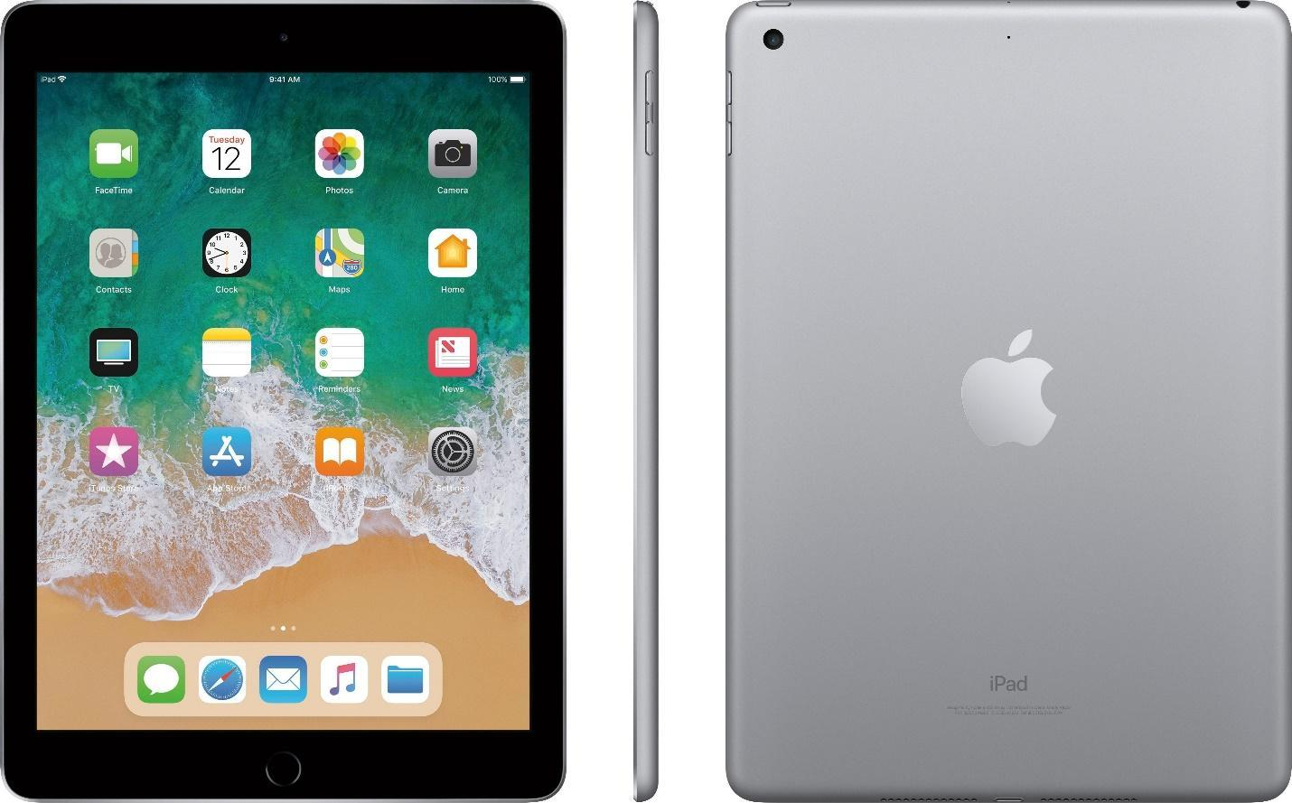

APP

